**Hibernate in java and spring boot**

Hibernate is a Java framework that simplifies the development of Java application to interact with the database. It is an open source, lightweight, ORM (Object Relational Mapping) tool. Hibernate implements the specifications of JPA (Java Persistence API) for data persistence.

ORM Tool

An ORM tool simplifies the data creation, data manipulation and data access. It is a programming technique that maps the object to the data stored in the database.

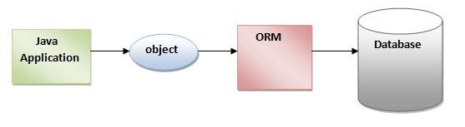

## Advantages of Hibernate Framework

### **1.Open Source and Lightweight**

### **2.Fast Performance**

### **3.Database Independent Query**

### **4.Automatic Table Creation**

### **5.Simplifies Complex Join**

### **6.Provides Query Statistics and Database Status**

**Mapping:**

hibernate mappings are one of the key features of hibernate . they **establish the relationship between two database tables as attributes in your model**

**Types of Mapping:**

**1.one to one Mapping**

**2.one to many mapping**

**3.many to one mapping**

**4.many to many mapping**

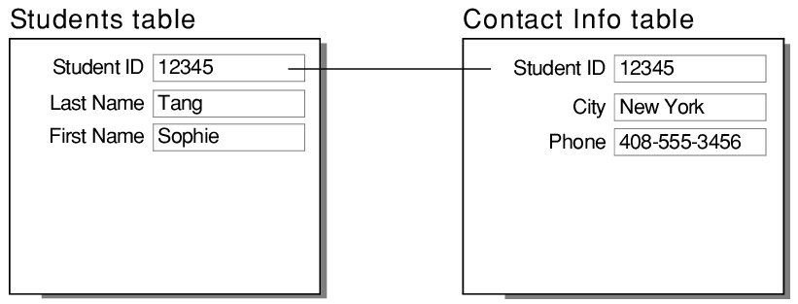

**One to many:**

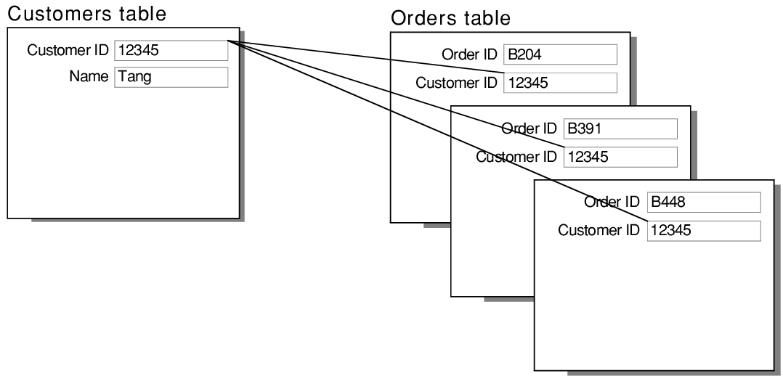

**Many to one:**

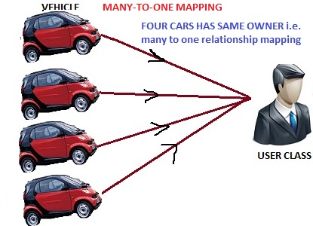

**Many to many**

